TEAM ID :NM2023TMID13345

COLLEGE NAME: JAYAM COLLEGE OF ENGINEERING AND TECHNOLOGY

PROJECT :SOLAR PANEL FORECATING

INTRODUCTION:

The deployment of solar –based electricity generation, especially in the form of photovoltaics (PV), has increased in recent years due to a wide range of factors such as concern about greenhouse gas emissions, government policies and lower equipment costs. There are a number of challenges to the reliable and efficient integration of solar energy. Chief among them will be the development of new tools and practices that manage the variability and uncertainty of solar power.
Short term uncertainty (up to a week ahead) can be managed by many solutions, including increased demand side participation, greater coordination between balancing areas, and deployment of flexible but often expensive resources such as energy storage. However, one of the most effective and least BAcost ways to integrate solar, particularly at penetration levels currently experienced, is to forecast the expected power output and use that to more reliably and efficiently operate the system.
Solar forecasts are used by a variety of stakeholders in the power industry. System operators are using solar forecasts to schedule generation, procure operating reserves and ensure there is sufficient flexibility to manage changes in output. Market participants use forecasts to manage their generation portfolios. For example, in Germany, 38 GW of solar capacity is traded on the energy market. This amount of solar power has a strong impact on the market price, so even traders who do not sell solar energy use solar forecasts.
Previous issues of this magazine have provided an overview of wind forecasting, including the production of wind power forecasts and their end use. While similar to wind in many aspects, solar forecasting has its own unique characteristics related to forecasting, which are explored in this article. One aspect of solar power forecasting that differentiates it from wind is that much of the variability and uncertainty is related to visible cloud movement. This can be forecasted in the short term by technologies such as ground-based sky imaging and satellite imaging systems, which are described here together with potential drawbacks related to cloud formation and dissipation.
The underlying “clear sky” solar PV output is easily calculated based on the position of the solar panels relative to the sun, so the main challenges are to predict the actual irradiance at the solar
panels given the influence of clouds, aerosols and other atmospheric constituents, and the temperature-dependent PV panel efficiency. Adding to the challenge, large amounts of solar are being installed on the distribution system, often behind-the-meter (BTM), meaning that only load netted with the solar generation is seen by transmission system operators rather than knowing the output of the solar system.
This article will outline methods used to produce solar PV power forecasts, focusing on aspects unique to solar forecasting. The nuances related to BTM solar forecasting and its interaction with load forecasting will be explored, with the current performance of solar forecasting summarized. We finish by discussing the improvements on the horizon that will give operators increased ability to forecast solar PV.
Current Solar Forecasting Techniques
Forecasting of solar output consists of a variety of methods based on the time frame being forecasted, the data available to the forecaster and the particular application of the forecast. In past editions of the magazine, wind forecasting articles covered many of those basic forecasting techniques that are also important for solar (see Further Reading). The methods are broadly categorized in Figure 1 according to the time horizon in which they generally show value. Methods common to wind and solar include Numerical Weather Prediction (NWP) and Model Output Statistics (MOS) to produce forecasts, as well as blending techniques that combine ensemble forecasts, Statistical Learning Methods and Climatology.
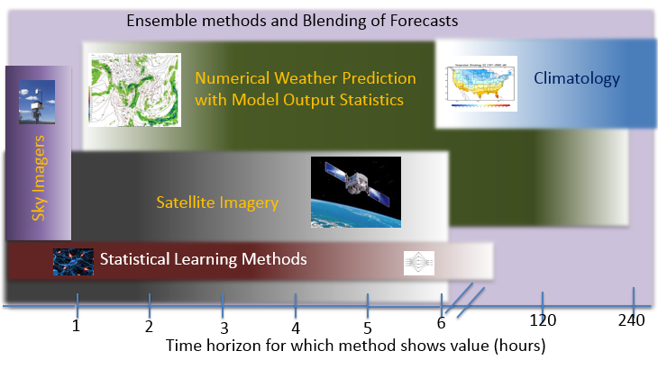
Figure 1: Generalized View of Solar Forecasting Methodologies based on Time Horizon for which they show value
To achieve the greatest accuracy, forecasters supply environmental inputs, such as irradiance and temperature to models that transpose the irradiance to the incident plane of array (i.e., taking the beam direction and solar panel orientation into account) and then convert the irradiance to power. Several methods can be used and these are described below beginning with those that perform best on the shortest look-ahead timeframes.
Time Series Prediction with Statistical Learning Methods: Direct observations of irradiance (such as from pyranometers or other measurement devices) can be used with time series statistical learning methods to project subsequent conditions. Historical records of site irradiance are used to train the methods, while real-time measurements identify the current condition from which to base the forecast. Methods used include artificial neural networks, regression models, autoregressive models, support vector machines, Markov Chains, and blended methods, such as using genetic algorithms to optimize a neural network. These methods work best for the intra-hour time horizon, but may have some value out to two to three hours or more, especially when used in combination with other methods.
Sky imagers: These are digital cameras that produce high-quality images of the sky from horizon to horizon, which are used for detection of clouds, estimating cloud height above ground, and calculating cloud motion. Clouds scatter some wavelengths of light more than others, which can be used to categorize thick and thin clouds as well as to differentiate them from aerosols or dust. Consecutive images can estimate cloud velocity, and thus can provide a very short-horizon forecast. If additional sky imagers are available, triangulation can provide information on cloud base and depth as well as differential advection speed at different cloud levels. Sky imagers are of significantly decreasing value beyond approximately a 30-minute time frame, and are expensive to use relative to most other forms of very short-term prediction.
Satellite Imaging: Providing value for a longer look-ahead time frame, geostationary satellite data from networks such as NOAA’s Geostationary Operational Environmental Satellite (“GOES”) network in North and South America, and the MeteoSat network for Europe/Africa/Central Asia can provide information about cloud properties and movement. First, a physically-driven model predicts the clear sky conditions at a specific site, using inputs like aerosol content, water vapor, elevation and ozone. This modeled clear sky irradiance is then modulated by estimated irradiance derived from satellite images. Sequential satellite images can be combined to create cloud motion vector fields that can be used to predict future cloud locations. This technique has been shown to be effective in forecasting irradiance from 1-minute ahead to as far as five-hours ahead. It performs less effectively during conditions when clouds are rapidly forming or dissipating, such as convective and marine layer cloud regimes.
Numerical Weather Prediction (NWP): These systems have been the workhorse of forecasting applications for many years. Traditionally, these have performed best for the time horizon from 6 hours to 2 weeks; recently deployed rapid update systems (such as the High Resolution Rapid Refresh system) can provide value at shorter time scales. NWP methods have been well described in previous magazine articles in relation to wind, and involve solving the Navier-Stokes equations to model the weather, combined with modules that compute other physical processes, such as radiative transfer, land surface models and cloud microphysics parameterizations.
Historically, these models have been optimized for predicting variables such as temperature, humidity, probability of precipitation, and wind. It is only recently that there has been an emphasis on improving prediction of surface solar irradiance. Statistical learning methods are often used to correct for errors in the NWP model output and to blend output from multiple models in a process referred to as Model Output Statistics (MOS). It is typical for such methods to improve upon the raw forecast of an NWP model by about 10-15%.
Ensemble Forecasting
Ensemble forecasts are important for estimating the uncertainty in solar power forecasting, which is particularly important during morning and evening ramps, cloud cover and fog. An ensemble consists of a collection of forecasts and can represent the uncertainty in the calculation of the state of the atmosphere inherent in forecasting methods. There are two major techniques for creating an ensemble – the first adds perturbations to the initial state of a forecasting model, while the second type uses different numerical models or physics schemes. Both types provide insights into the likelihood of extreme events, such as ramps of solar output due to changes in cloud cover, fog or other atmospheric features. Ensembles can be applied to any forecasting approach, although they are most well developed for NWP.
Ensemble forecasts for solar generation are used in power markets where the uncertainty of these forecasts provides an indication of price volatility. Other applications may be to help in reserve determination or scheduling of generation. Percentiles can be used to make the uncertainty visible and easy to interpret in such real-world applications. Fig. 3 shows how percentile “bands” change in size around a mean value (white line) and the true generation (black line). Percentiles represent a value below which the given percentage of the outcomes is expected to fall. For example, 10% of the outcomes should fall below the 10th percentile (P10) value, while 90% of the outcomes should fall below the 90th percentile (P90) value.
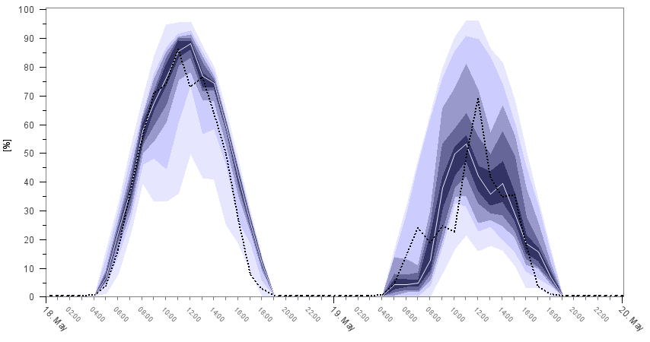
Figure 3: Example of a 2-day solar power forecast with 9 percentiles (P10 through P90) and the actual measurements (black dotted line)
Distributed and Behind-the-Meter Solar PV forecasting
A number of factors can impact on how solar forecasts are developed and used, particularly when the solar is connected to the distribution network or is Behind-the-Meter (BTM):
Whether the generation of a commercial or residential solar power system is recorded on its own or aggregated with customer load.
Whether telemetered meter data is available in real-time.
Whether detailed static data (“metadata”), including the plant location, PV geometry, nearby obstructions and hardware information is available.
At a large solar plant, meter data is typically available in near-real time and site metadata is generally known. For smaller distribution connected plants dedicated meter data is usually recorded but is often not telemetered in real-time. Meta-data may be difficult to obtain too. For BTM solar, real-time generator data is rarely known, meter data is often net of load and meta-data is difficult to obtain.
Therefore, distribution connected PV, in particular BTM PV, can be more difficult to forecast. If detailed metadata are available, they can be combined with a source for irradiance and weather data, typically from satellite and/or NWP sources described earlier. For example, information about all PV systems in the state of California is recorded and then combined with high-resolution irradiance values and weather predictions to forecast output for the entire state. This “bottom up” approach is employed by the California Independent System Operator to predict the total contribution of BTM solar on their grid, as shown in Figure 3
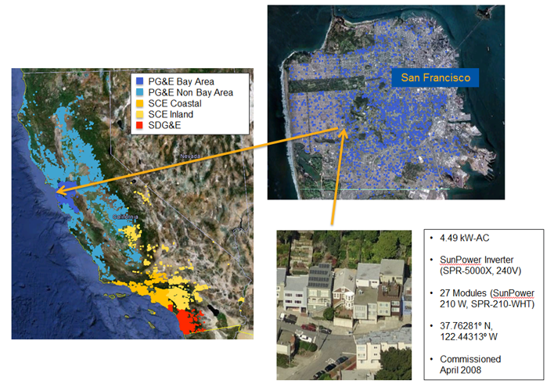
Figure 3: Detailed site information and weather data, aggregated to fleet level for the three major IOUs in the state of CA. Courtesy Clean Power Research
This approach has become quite cost-effective, particularly for areas with large amounts of distributed PV, such as in California where they have surpassed 200,000 unique PV systems. It allows for aggregation to large areas to support ISO and utility-wide prediction, but also for regional analysis, where distribution system operators and planners need to understand localized impacts. One potential benefit of this approach is that the particulars of each system are explicitly captured. For example, a PV system that is oriented toward the east will produce a different power curve than a south- or west-facing system and thus the fleet composition will influence the resulting power profile for the overall system. Challenges, however, do exist for this approach. While most hardware, location and orientation information is typically well documented, dynamic elements about each PV installation, such as shading and hardware system availability will also impact the accuracy of the prediction. Suitable approaches are being developed to account for these impacts.

In applications where the objective is forecasting aggregated PV production or net load across a large system, and/or where detailed data do not exist, other less detailed prediction methods can be deployed based on combinations of existing data, such as substation loads and regional meteorological data. This “top down” approach has the advantage of limited data requirements. Whereas the bottom up approach uses validated models applied to each system, the less detailed top down approach requires comparison to metered data on a statistically significant number of sites for benchmarking its overall accuracy. Challenges with this approach center on the representation of the statistical sample to adequately depict the total solar contribution. Ongoing research is focused on determining the detail of system data required based on the given PV penetration. It is important to recognize that different end users may have different requirements for the amount of detail needed.
As an example, the forecasts for Transmission System Operators and Distribution System Operators in Germany are calibrated and evaluated against estimations of the solar production on a ZIP code level (Figure 4). Forecasts of aggregate BTM PV production are developed and validated based on the up-scaling of output from a select subset of representative PV sites. The real-time solar production is directly obtained from the solar inverters of these installations, through companies that install PV modules and monitor their performance. This approach has two main advantages: first, the grid operator can predict solar output in real-time, and second, the forecasts can be optimized on a regional level.
Comparison between these estimations and metered data show very good agreement. This approach requires consideration in the selection of the representative sites, for which sufficiently granular and reliable production data are required. Further, real-time telemetry is required, if these sites serve as the basis for nowcasting (i.e. at horizons of one hour or less). This approach provides an example of the data and telemetry requirements that will be important, and that system operators, distribution utilities and others will have to consider in their planning and interconnection processes.
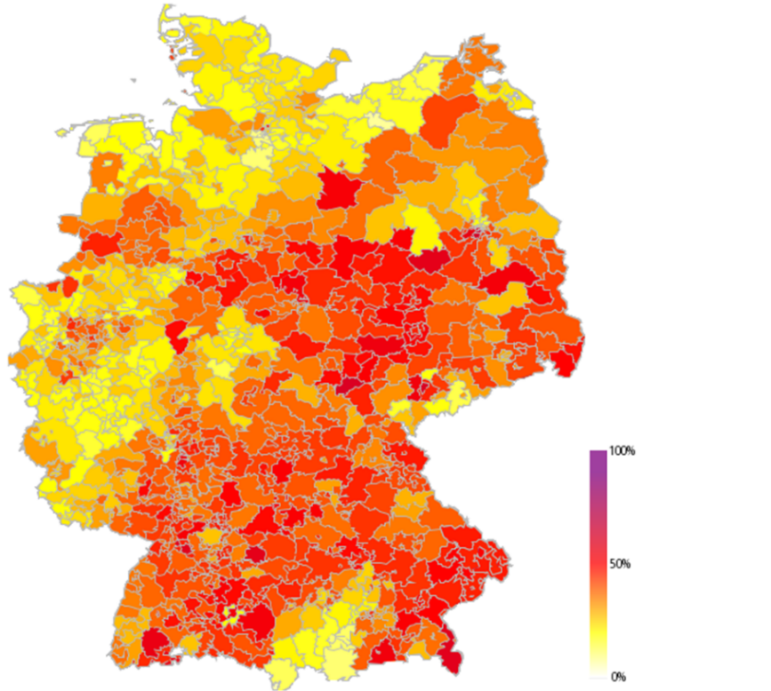
Figure 4: Real-time estimation of the solar power production on ZIP code level in Germany based on online data from inverters. Source: energy & meteo systems
Current Experience and Performance of solar forecasting
A key question for operators and other end users is “how well do solar forecasts perform?” The answer depends on a number of aspects, many of which are also relevant for wind forecasting. As an example, any forecast performance metric should be tied to the end use application’s sensitivity to forecast error. However, many users (system operators, traders, utilities, etc.) may not have a quantitative understanding of their sensitivity to forecast error and the related value of their forecast. Therefore, a standard set of widely used metrics is typically used. Standardized metrics facilitate the comparison of solar forecasts, but may not accurately inform a specific user as to which forecasts provide the most value for their specific application.

Three widely used metrics are employed for assessing the deterministic point forecasts most commonly used today: Mean (bias) Error (ME or MBE), Mean Absolute Error (MAE) and Root Mean Square Error (RMSE). These metrics may be applied using different approaches. The most widely used approach, as followed here, is to express the metrics as a percentage of the installed capacity over all daylight hours. Other approaches calculate the percentage change in these metrics relative to a reference forecast (persistence or climatology), or as a percentage of average actual production over the evaluation period. There is a movement toward comparing to “smart persistence”, which assumes that the relevant conditions such as cloud cover and temperature remain the same, but the underlying variation due to changing solar angle is included in the baseline. These metrics are simple to compute but one still needs to interpret the resulting metric values. Forecast performance is impacted by many factors, as described below.

Look Ahead Time: One of the most intuitive factors that impact forecast performance is the forecast look-ahead time (also known as the forecast time horizon or lead time). Figure 5 shows an example development of the forecast error (error growth) over a forecast horizon of 85h. The figure depicts the MAE for 2 years for the aggregate solar generation in Spain, although the pattern is somewhat typical for both individual facilities and aggregates of facilities. The MAE rises rapidly over the first few hours after the issue time. After about 6 hours, the rate of error growth decreases substantially. It can also be seen that forecasting performance improves with further forecast system development in the region, as 2014 shows a significantly lower error than 2013.
Figure 5: Forecast performance over the look ahead period of the forecast for aggregated 4.4 GW PV in Spain.
Variability in Solar Production: In general terms, absolute forecast performance is impacted strongly by the amount of atmospheric-based variability in the solar power production. For example, the absolute level of impact of clouds on solar irradiance is lower near sunrise or sunset although the relative variation (% of average irradiance change) may be much larger. Thus, variability in production and the magnitude of forecast errors tend to follow the diurnal cycle. This is illustrated in Figure 7 for a non-tracking facility in Texas. The relationship between the diurnal cycle of variability and MAE is clearly evident in data presented in this chart.
Specific Plant Attributes: The various plant attributes of a solar generation facility are also important, and illustrated in Figure 6. The solid lines show the variability and MAE for a dual axis tracking facility that is located close (i.e. very similar weather regimes) to a facility without tracking as represented by the dashed lines. The chart indicates that the variability and MAE for both facilities is similar at midday and near sunrise and sunset. However, the variability and MAE of the dual axis tracker is substantially higher during the mid-morning and mid-afternoon hours. The impact of this pattern on the overall forecast MAE for the two sites is quite substantial.

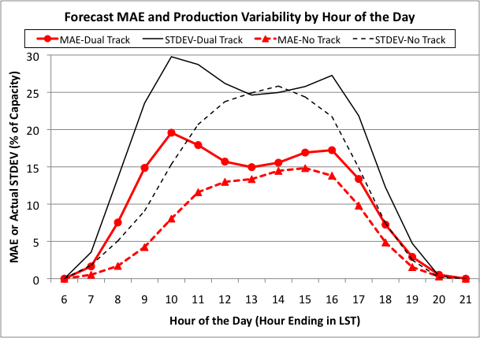
Figure 6: Annual MAE vs. variability (observed standard deviation) by hour of the day for a non-tracking facility (red) and a nearby dual-axis tracking (black) facility in Texas.

Spatial Scale: A fourth factor that has a significant impact on forecast performance is the spatial scale of the generation. Due to the well-known “aggregation effect”, forecasts for geographically diverse aggregates of solar generation facilities have smaller errors than the forecasts for individual facilities in the aggregate. Local effects, which are more random and more difficult to forecast, tend to average away when we look at the aggregated forecast. A broad view of the effect of aggregation on the performance of day-ahead solar power production forecasts is depicted in Figure 8. This chart shows the annual MAE over all daylight hours for day-ahead forecasts for a broad spectrum ranging from individual centralized facilities to regional and system-wide aggregates of centralized facilities and distributed generation. The power of the aggregation effect in reducing the absolute forecast errors is quite evident. Note many factors impact forecast performance for a given entity of a specific size, such as the geographic diversity in the entity, the attributes of the facilities (e.g. tracking vs. no tracking etc.), the amount of variability associated with local weather regimes and the causes of the variability.

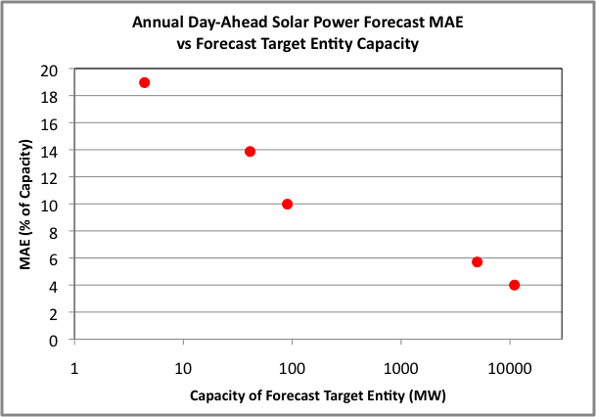
Figure 7: Relationship of the annual day-ahead solar power forecast MAE (% of capacity) over all daylight hours to the installed capacity of the forecast target entity for a broad spectrum of entities (individual facility, regional or system-wide aggregate).
Other weather phenomena: While forecasting cloud cover is a predominant factor for solar forecasting there are some other phenomena that can have a similar impact on predictability of PV generation, especially on day-ahead and longer time scales. These include fog, snow and dust. An example of the impact of fog and snow on the performance of forecasts for a large aggregate of generation facilities in Germany is shown in Figure 8. The errors are much larger in the spring and fall when fog is a significant factor in power production variability.
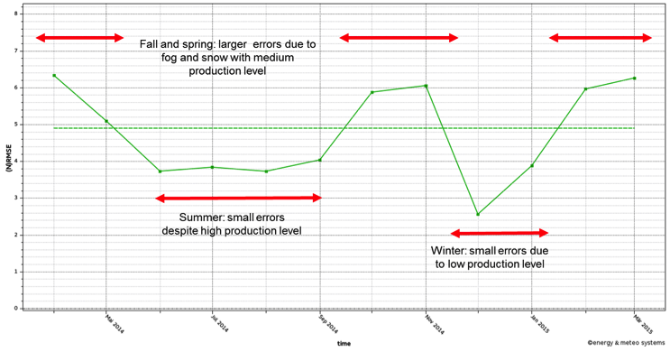
Figure 8: Day-ahead forecast RMSE by month for distributed and centralized solar power in Germany, showing impact of fog and snow.
Paths to improved solar forecasting
Solar power forecasting is still a relatively new technology. Individual methods have deficiencies, such as the lack of attention that NWP models have traditionally paid to cloud cover variables and the relative immaturity of sky imaging techniques, while the blending of different forecasting techniques is still less than optimal. The fact that much PV is BTM means some of the data needed to setup models may not be available and methods are still being developed to forecast this type of PV. Probabilistic forecasting techniques that could significantly improve upon representation of uncertainty are still being explored. Finally, ineffective communication of forecast information to the users and the lack of end use tools for using forecast information hinder the extraction of full value from forecasts.
A number of initiatives are currently underway in the US and Europe to improve in some of these key areas of solar power forecasting. These are covered in more detail in forums such as the Utility Variable Generation Integration Group (UVIG) annual forecasting workshop and the energy track of the American Meteorological Society, but the following describes the major research areas, with specific examples:
Atmospheric Modeling Enhancement and Blending of Methods: The US Department of Energy is currently funding several efforts to improve the underlying models for solar forecasting under their SunShot Initiative. This includes research by IBM on optimal blending of different models using machine learning strategies, and by NCAR on tuning individual models including sky imaging, satellite methods and a solar-tuned NWP model, which are then combined together to maximize the benefits of the individual methods. NOAA is adding various solar energy-related parameters such as outgoing longwave radiation and incoming shortwave radiation, as well as the direct and diffuse irradiance, to its hourly-updated Rapid Refresh models. Efforts are also ongoing in Europe that focus on improving fog, snow and dust representation in NWP models (for example, the MACCII project) and in academia, such as a University of Arizona project to develop a hybrid forecasting system at a high time resolution.
Incorporation of BTM into Load Forecasting Methods: The load forecasting community is evaluating different ways of incorporating BTM PV into existing load forecasts and the costs and benefits of using more detailed weather and PV system data, where available. In California, a number of government funded efforts are underway, using information about PV installations to predict the day-ahead and hour-ahead power output of the fleet. Clean Power Research has worked to integrate their solar forecasts into the Itron load forecasting tool, focusing on improvements to BTM forecast accuracy and integration of the direct power prediction into the neural net load forecasting framework.
Cloud Propagation Techniques: Sky imaging and satellite-based cloud propagation methods are still at early stages of development and several research groups are actively working to improve them. For instance, Colorado State University is developing a satellite-derived insolation forecast in concert with co-located winds from an NWP model to capture the movement of clouds at different heights. In the NCAR SunShot project, a cloud nowcasting prototype based on multiple satellite infrared sensors and a simplified NWP model compares infrared radiance observations with their equivalents from a numerical model to develop a more accurate cloud profile that can be used with the other forecasting methods.
Probabilistic forecasting: Ongoing research in this area includes improved probabilistic treatment of atmospheric physics models, as well as improved representation of uncertainties in cloud formation and decay. This will result in increased reliability and sharpness. One novel method is the analog ensemble approach, which instead of generating multiple model forecasts, searches the past history for similar forecasts and makes corrections to the forecast according to the error in prior forecasts. The prior analogs become an ensemble that quantify the uncertainty of the forecast.
Integration into System Operations: While improving the underlying forecasts is important, it is also crucial that they are integrated into system operations so that operators can obtain the full value from the forecast. Many utilities now receive forecasts; however most are still learning how to use them in their decision making processes. There are significant efforts to integrate solar power forecasts more deeply into system operations. For example, Hawaiian Electric Company has supported the development of a Solar and Wind Integrated Forecast Tool (SWIFT), which is built on an optimized mix of various approaches described earlier and has deterministic and probabilistic elements as well as variability and ramp rate predictions. Work is underway to integrate these forecast outputs directly into the energy management systems (EMS). The Red Eléctrica Control Centre of Renewable Energies in Spain, shown in Figure 9, can identify risks, anticipate the behavior of solar and wind and compensate for their variability, without compromising the quality and security of supply.
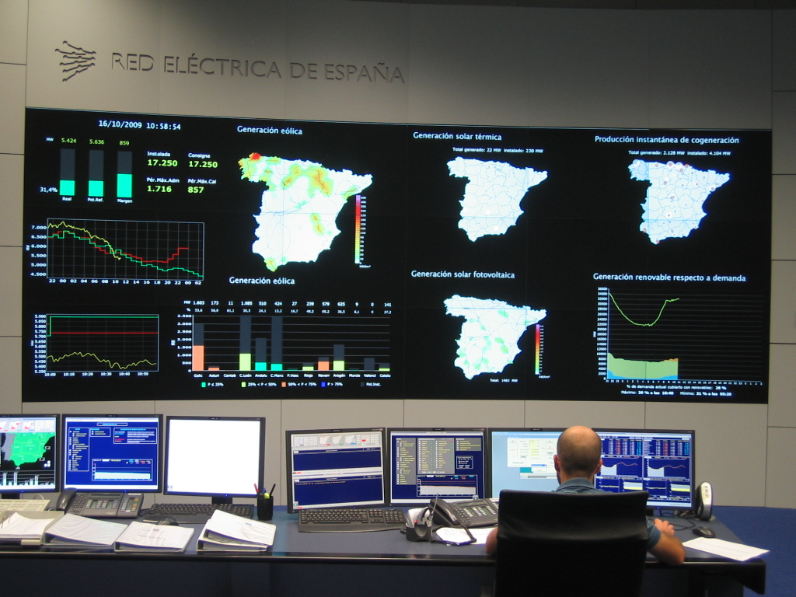
Figure 9: Red Eléctrica Control Centre of Renewable Energies (CECRE) in Spain
Research on methods to use probabilistic forecasts to optimize system operations, using stochastic optimization techniques, is being carried out in various institutions. For example, Sandia National Laboratories are developing a toolkit to demonstrate use of stochastic unit commitment, while the Electric Power Research Institute are investigating the use of probabilistic information to develop more intelligent operating reserve requirements. Power system operators and independent power producers could potentially see benefits by incorporating forecast uncertainty directly into their decision making.
Finally, the need for an ability to evaluate forecasts on the basis of the value they provide is driving several R&D efforts. As shown earlier, there are a variety of metrics that can be used, and currently there is typically not a direct link between forecast performance metrics and the value a forecast provides. To this end, the DOE efforts mentioned earlier are developing and demonstrating a set of useful metrics for assessing performance of deterministic and probabilistic forecasts against both error based metrics as well as metrics that link to the economic value of the forecast via production cost modeling and reserve analysis.
Summary/Conclusions
Solar forecasting is one of the lowest cost methods of efficiently integrating solar energy. In this article, we have focused on the current state of solar forecasting and identified key issues related to its development and application. The process of solar forecasting for various time horizons, methods and applications has many similarities to wind forecasting, but as solar output is strongly linked with cloud cover, there are other considerations and possibilities.

Most NWP models do not run at spatial resolutions that are high enough to explicitly model clouds and do not use detailed data about cloud cover and cloud formation when initializing. This means the first 3 to 6 hours of most current NWP models are not particularly useful for solar forecasting. As a result methods such as sky imaging and satellite data have been used to predict near term solar output, with some success. Additionally, increases in model resolution and more frequently updated models are helping advance forecasting of solar irradiance in NWP. Even with improved accuracy, it will still be important to quantify the uncertainty in the forecast in order to ensure efficient integration, and we described various methods for quantifying uncertainty.

As performance is a key parameter to any new development, we demonstrated how accuracy can be measured and evaluated, with a focus on how the metrics can influence the end result. We showed some of the key factors driving uncertainty such as look-ahead horizon, forecasting interval width, tracking systems and system size. By considering these factors in plant design and electric system design we can reduce uncertainty and thus lower the cost to integrate solar energy.

BTM PV is likely to provide a large part of society’s energy needs in the future. Both detailed bottom-up forecasting methods and aggregated top-down forecasting methods can be used to manage BTM solar. While detailed methods are likely to be more accurate, data is not always available, and certain applications may not require such a fine level of detail. With increasing penetration of BTM PV, data provision and availability will become increasingly important for successful forecasting and integration. This includes improved representation of static site data, but also, where possible, increased access to telemetered output data or historical meter data. Ongoing research focuses on all aspects of the value chain of forecasting, including not just improvement of the underlying forecasting methods and combination of different forecasting techniques, but also on the ways that solar forecasts are valued and used in operations.

PURPOSE:

Solar power forecasting is the process of gathering and analyzing data in order to predict solar power generation on various time horizons with the goal to mitigate the impact of solar intermittency. Solar power forecasts are used for efficient management of the electric grid and for power trading.

PROBLEM STATEMENT DEFINITION:

PROPOSED SOLUTION:

Solar power is quickly becoming known as the best energy solution that we have for saving our planet. Solar energy has a plethora of benefits since it is derived from the sun’s radiation, which is a very powerful energy source. The best way to harness the power of the sun’s power is by installing solar panels for homes and businesses.
The sun provides enough energy in just ONE HOUR to meet our global energy needs for a whole year. Let that sink in! Below we go into more detail about solar power, the benefits, and why you should consider it.
The Benefits Of Solar Power
Solar power, unlike traditional power, is renewable. This means it can be harnessed all over the world and is available every day. It’s also far more sustainable than using traditional power. It reduces energy bills in the long run, as you have the initial cost to consider, but over time you will save money. The amount you save will depend on your energy usage and the size of the solar power system, so bear that in mind.
Solar power also has many diverse uses and applications. You can generate electricity or heat using this method. Solar energy can also be used to produce electricity in areas without access to the energy grid, to distil water in regions that have limited clean water supplies and to power satellites in space.
There are lower maintenance costs for solar power as well. All you have to do is keep your solar panels clean, cleaning them a few times a year to take full advantage of this cost-saving solution. This makes solar very cost-effective over time. Even if you pay a professional to clean your panels, solar power remains a cost-effective solution. Depending on your location, there may be rebates and incentives for those who decide to introduce solar power into their homes or business to further offset costs.
Solar energy also helps you to boost your energy-independence. You can protect yourself against a rise in utility pricing, ensuring you are benefiting from cheap electricity the entire day. Solar battery storage systems can also help store electricity for nighttime and rainy days, so you don’t have to worry about those limiting factors.
How Solar Power Helps The Environment
Solar power is not only beneficial for those who use it, but it also creates clean, renewable power, so it benefits the environment immensely. It is a fantastic alternative to fossil fuels, can reduce the carbon footprint we all make in the world, and reduces greenhouse gases around the world.
We must all be more concerned with the environment and our impact on it, and using solar power is a great way to ensure we are doing the best by our planet.
Why Solar Power Is Beneficial For Businesses
Solar power isn’t only beneficial for homeowners; it can be beneficial for businesses, too. In some cases, owners of newly installed systems can get a federal tax credit. You will also be able to deduct a huge percentage of the cost of your investment, helping you to offset much of the upfront cost.
As your solar system will require little to no maintenance, you won’t have to worry about spending money or taking care of it yourself. You also can improve your business image as you’ll be a ‘greener’ business, attracting environmentalists and other people who care about the impact they make on the environment. Becoming a green business is not only good for the planet, but it’s also good for your image and marketing. It can help to set you apart from competitors and similar businesses in your industry.
Since 2011, solar panel prices have dropped more than 80%. In fact, the majority of small businesses will not have to worry about spending any money upfront because flexible options are available. You may be able to secure a solar loan or lease or be provided with a flexible investment option.
It’s easy for any business to go solar with the options available. Solar energy consulting services can help you to figure out what’s right for your business and come up with a payment solution to suit.
Conclusion:
Solar power is our best energy solution to keep our future clean. There are far too many benefits for homeowners, businesses, and the planet for us to ignore solar as a viable energy source. Energy efficiency consulting is available for those who are willing to take the next smart step on their journey to help themselves and the environment.
You may also like to read
Impact Solar Energy Will Have On The Coal Industry
About Verde Solutions
Verde Solutions is full service, energy efficiency consulting firm founded on three main principles; Innovation, Sustainability, and Efficiency. At Verde, we create value for our clients and communities by providing innovative energy efficient solutions. By reducing energy use and utilizing renewable energy, we lower costs and set a sustainable path for the future.

FUNDAMENTAL REQUIREMENT:

Solar power forecasting is the process of gathering and analyzing data in order to predict solar power generation on various time horizons with the goal to mitigate the impact of solar intermittency. Solar power forecasts are used for efficient management of the electric grid and for power trading.
As major barriers to solar energy implementation, such as materials cost and low conversion efficiency, continue to fall, issues of intermittency and reliability have come to the fore. The intermittency issue has been successfully addressed and mitigated by solar forecasting in many cases.
Information used for the solar power forecast usually includes the Sun´s path, the atmospheric conditions, the scattering of light and the characteristics of the solar energy plant.
Generally, the solar forecasting techniques depend on the forecasting horizon
Nowcasting (forecasting 3–4 hours ahead),
Short-term forecasting (up to seven days ahead) and
Long-term forecasting (weeks, months, years)
Many solar resource forecasting methodologies were proposed since the 1970 and most authors agree that different forecast horizons require different methodologies. Forecast horizons below 1 hour typically require ground based sky imagery and sophisticated time series and machine learning models. Intra-day horizons, normally forecasting irradiance values up to 4 or 6 hours ahead, require satellite images and irradiance models. Forecast horizons exceeding 6 hours usually rely on outputs from numerical weather prediction (NWP) models.
Nowcasting
Solar power nowcasting refers to the prediction of solar power output over time horizons of tens to hundreds of minutes ahead of time with up to 90% predictability. Solar power nowcasting services are usually related to temporal resolutions of 5 to 15 minutes, with updates as frequent as every minute.
The high resolution required for accurate nowcast techniques require high resolution data input including ground imagery, as well as fast data acquisition form irradiance sensors and fast processing speeds.
The actual nowcast is than frequently enhanced by e.g. Statistical techniques. In the case of nowcasting, these techniques are usually based on time series processing of measurement data, including meteorological observations and power output measurements from a solar power facility. What then follows is the creation of a training dataset to tune the parameters of a model, before evaluation of model performance against a separate testing dataset. This class of techniques includes the use of any kind of statistical approach, such as autoregressive moving averages (ARMA, ARIMA, etc.), as well as machine learning techniques such as neural networks, support vector machines (etc.) .
An important element of nowcasting solar power are ground based sky observations and basically all intra-day forecasts.[9]
Short-term solar power forecasting[edit]
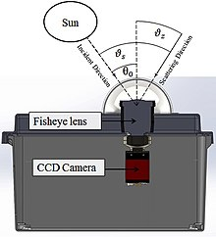

An example of sky-imager used for detecting, tracking and predicting cloud cover conditions in the vicinity of a solar energy facility of interest. Most often, these devices are used to make estimates of solar irradiance from the images using local calibration by a pyranometer. The solar irradiance short-term forecasts are then fed into PV power modelling routines to generate a solar power forecast.
Credit: UC San Diego
Short-term forecasting provides predictions up to seven days ahead. Due to the power market regulation in many jurisdictions, intra-day forecasts and day-ahead solar power forecasts are the most important time horizons in this category. Basically all highly accurate short term forecasting methods leverage serval data input streams such as meteorological variables, local weather phenomena and ground observations along with complex mathematical models.
Ground based sky observations
For intra-day forecasts, local cloud information is acquired by one or several ground-based sky imagers at high frequency (1 minute or less). The combination of these images and local weather measurement information are processed to simulate cloud motion vectors and optical depth to obtain forecasts up to 30 minutes ahead.
Satellite based methods
These methods leverage the several geostationary Earth observing weather satellites (such as Meteosat Second Generation (MSG) fleet) to detect, characterise, track and predict the future locations of cloud cover. These satellites make it possible to generate solar power forecasts over broad regions through the application of image processing and forecasting algorithms. Some satellite based forecasting algorithms include cloud motion vectors (CMVs) or streamline based approaches.
Numerical weather prediction[edit]
Most of the short term forecast approaches use numerical weather prediction models (NWP) that provide an important estimation of the development of weather variables. The models used included the Global Forecast System (GFS) or data provided by the European Center for Medium Range Weather Forecasting (ECMWF). These two models are considered the state of the art of global forecast models, which provide meteorological forecasts all over the world.
In order to increase spatial and temporal resolution of these models, other models have been developed which are generally called mesoscale models. Among others, HIRLAM, WRF or MM5. Since these NWP models are highly complex and difficult to run on local computers, these variables are usually considered as exogeneous inputs to solar irradiance models and ingested form the respective data provider. Best forecasting results are achieved with data assimilation.
Some researchers argue for the use of post-processing techniques, once the models’ output is obtained, in order to obtain a probabilistic point of view of the accuracy of the output. This is usually done with ensemble techniques that mix different outputs of different models perturbed in strategic meteorological values and finally provide a better estimate of those variables and a degree of uncertainty, like in the model proposed by Bacher et al. (2009).
Long-term solar power forecasting
Long-term forecasting usually refers to forecasting techniques applied to time horizons on the order of weeks to years. These time horizons can be relevant for energy producers to negotiate contracts with financial entities or utilities that distribute the generated energy.
In general, these long-term forecasting horizons usually rely on NWP and climatological models. Additionally, most of the forecasting methods are based on mesoscale models fed with reanalysis data as input. Output can also be postprocessed with statistical approaches based on measured data. Due to the fact that this time horizon is less relevant from an operational perspective and much harder to model and validate, only about 5% of solar forecasting publications consider this horizon.
Energetic models
Any output from a model must then be converted to the electric energy that a particular solar PV plant will produce. This step is usually done with statistical approaches that try to correlate the amount of available resource with the metered power output. The main advantage of these methods is that the meteorological prediction error, which is the main component of the global error, might be reduced taking into account the uncertainty of the prediction.
As it was mentioned before and detailed in Heinemann et al., these statistical approaches comprises from ARMA models, neural networks, support vector machines, etc. On the other hand, there also exist theoretical models that describe how a power plant converts the meteorological resource into electric energy, as described in Alonso et al. The main advantage of this type of models is that when they are fitted, they are really accurate, although they are too sensitive to the meteorological prediction error, which is usually amplified by these models. Hybrid models, finally, are a combination of these two models and they seem to be a promising approach that can outperform each of them individually.

DATA FLOW DIAGRAM:
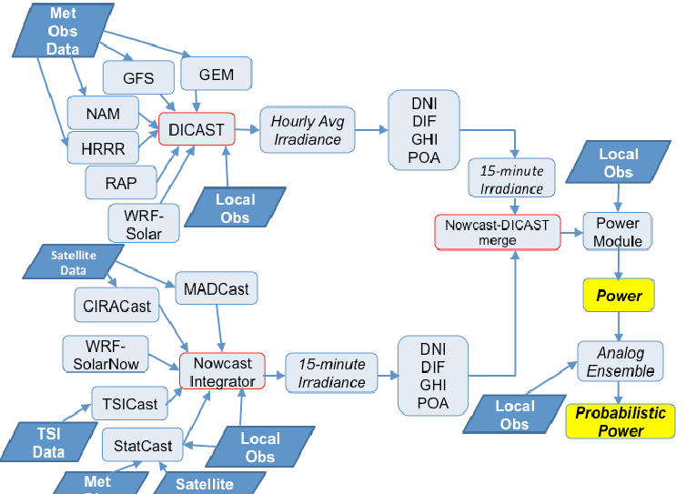

Fig 0.1:DATA FLOW DIAGRAM

FLOW CHART:

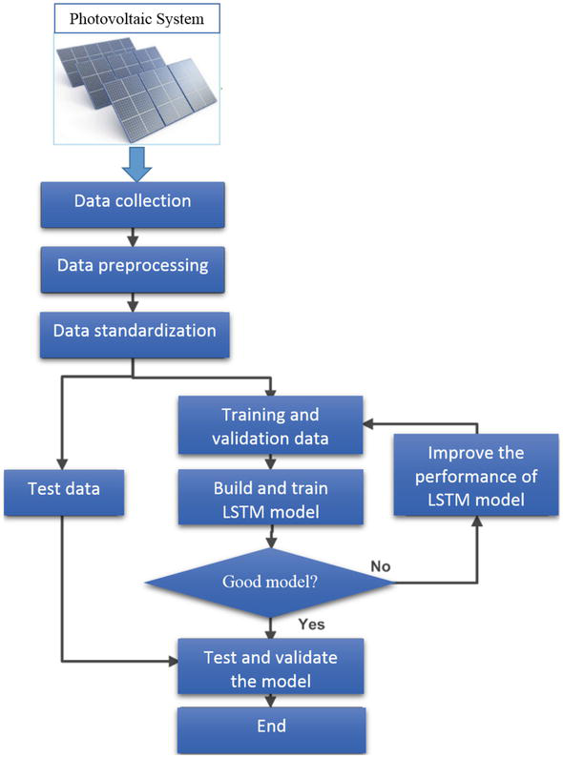

Fig 0.2:FLOW CHART

CODING FOR SOLAR PANEL FORECASTING:

Feature engineering:

Here, let’s create new features from existing ones to make categorical variables usable in our machine learning algorithms and also capture more patterns in the data.
First, we perform the encoding of categorical variables namely location and season using the one-hot encoding method.
# Encode location data
df_with_location_en = pd.get_dummies(df, columns=['Location'], drop_first=True)# Encode season data
df_with_loc_season_en = pd.get_dummies(df_with_location_en, columns=['Season'], drop_first=True)
# Define time bounds in data
min_hour_of_interest = 10
max_hour_of_interest = 15# Calculate time lapse since onset of power generation
df_with_loc_season_en['delta_hr']= df_with_loc_season_en.Hour -
min_hour_of_interest# Create cyclic month features
df_with_loc_season_en['sine_mon']=
np.sin((df_with_loc_season_en.Month - 1)*np.pi/11)
df_with_loc_season_en['cos_mon']=
np.cos((df_with_loc_season_en.Month - 1)*np.pi/11)# Create cyclic hour features
df_with_loc_season_en['sine_hr']=
np.sin((df_with_loc_season_en.delta_hr*np.pi/(max_hour_of_interest
- min_hour_of_interest)))
df_with_loc_season_en['cos_hr']=
np.cos((df_with_loc_season_en.delta_hr*np.pi/(max_hour_of_interest
- min_hour_of_interest)))

The final list of features used for modeling is shown below:
selected_columns = ['Latitude', 'Humidity', 'AmbientTemp',
'PolyPwr', 'Wind.Speed', 'Visibility',
'Pressure', 'Cloud.Ceiling', 'Location_Grissom',
'Location_Hill Weber', 'Location_JDMT',
'Location_Kahului', 'Location_MNANG',
'Location_Malmstrom', 'Location_March AFB',
'Location_Offutt', 'Location_Peterson',
'Location_Travis',
'Location_USAFA','Season_Spring',
'Season_Summer', 'Season_Winter', 'sine_mon',
'cos_mon', 'sine_hr', 'cos_hr']
Data splitting
The entire dataset is split into 80% training data and 20% test data. The test data is held out and unseen throughout the hyper-parameter tuning and training of the different models.

Modeling
Three models (Random Forest — RF, Light Gradient Boosting Machine — LGBM, and Deep Neural Network — DNN) and a stacked ensemble were developed and compared with a baseline (K Nearest Neighbors— KNN) model.
Metrics
The R-squared metric is the ultimate metric for selecting the best-performed model in this analysis. Other metrics useful for assessing the performance of selected models include root mean squared error (RMSE) and mean absolute error (MAE).
R-squared
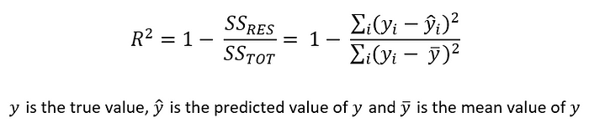

RMSE
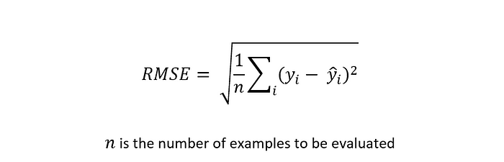

MAE


Results:
Cross-validation scores

The cross-validation (CV) R-squared scores for 1000 random permutations of hyper-parameters for different algorithms are shown in the boxplot below:
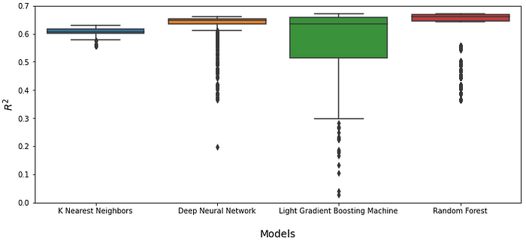
As shown on the boxplot, the LGBM model is the most sensitive to hyper-parameters selection while KNN is the least sensitive.

Next, the best CV scores for each algorithm type is displayed below:

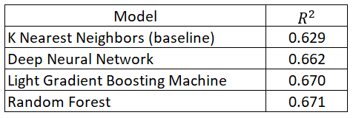

Results show that the best RF model has the highest CV score across all algorithms investigated.

Test data scores
The performance of each model is evaluated using the hold-out set which is 20% of the entire dataset. The results are summarized below:
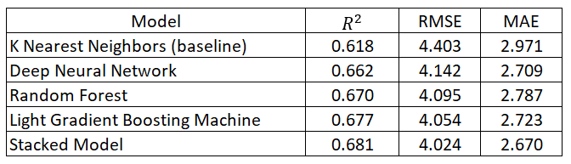

The stacked model has the overall best performance with a 10% improvement compared with the KNN (baseline) model. In addition, the LGBM model is the best base model based on all metrics considered.
It should be noted that all models generalize well to the unseen test set with comparable performance between CV and test scores.

Conclusions:

Standard data science techniques have been applied to predicting the solar power output in 12 different locations. The results show that LGBM is the best base model while the stacked model gave the overall best performance.
The best model may be further trained for individual locations to achieve even better scores however, that is not covered in this analysis.
Finally, the approach followed in this work can be used as a standard procedure to solve predictive analytics problems in the renewable energy space.

